2019 Mike Colalillo Medal of Honor
Scholarship Application

Applicant undergraduate status as of Fall Semester 2019 (check one)

[ ] Freshman [ ] Sophomore [ ] Junior [ ] Senior

Applicant’s Full Name_________________________________________________________

Mailing address:

Street _________________________________________________________________

City _______________________________ State ________ Zip code _____________

If temporary, add permanent address:

Street _________________________________________________________________

City _______________________________ State ________ Zip code _____________

E-mail address: __________________________ Phone: ____________________________

Date of birth: ___/___/______ Place of birth: ___________________________________

Higher Education Institution: __________________________________________________

Street __________________________________________________________________

City _______________________________ State ________ Zip code ______________

Academic Advisor: ____________________________________________________________

Phone: ___________________________ Email: _____________________________

I have read the eligibility requirements (on the reverse), I am eligible to participate, and I agree to the terms. In addition, I am aware that the research paper will become the property of the St. Louis County Historical Society and may be published online.

Applicant signature: ______________________________________Date: _______________
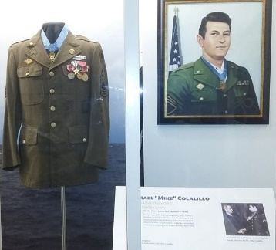
Return applications to:
St. Louis County Historical Society
Veterans Memorial Hall Program
506 Michigan Street
Duluth, MN 55802

*You may be required to provide proof of residency.

Eligibility Criteria and Terms

In order to be eligible, applicants need to be:

- A full-time student enrolled in a higher education institution in St. Louis County,
OR
- A resident* of St. Louis County, Minnesota, who is a full-time student enrolled in a higher education institution outside of St. Louis County, Minnesota.

Deadline for Submitting the Application

The 2019 application deadline is Thursday October 24, 2019.

What are we looking for?

We are looking for college students to produce a military history project relevant to St. Louis County, Minnesota veterans.

- A research paper that may address a historical event in St. Louis County, Minnesota, related to a conflict, a war, events on the home front, or that tells the story of a county veteran.
- Minimum of four (4) / maximum of ten (10) double-spaced pages;
- Research papers must include a bibliography;
- Research papers must include the list of sources secured from the Albert J. Amatuzio Research Center (part of the St. Louis County Historical Society).**

** A minimum of one resource from the Albert J. Amatuzio Research Center must be referenced. Curatorial staff and the VMH Program Assistant are available to assist applicants with possible ideas for research, by appointment: Monday – Friday from 10 AM to 3 PM. Please call 218-576-3114 or 218.733.7500 to make an appointment.

If you have specific research questions, you can email them to: charlene@thehistorypeople.org or to jay@thehistorypeople.org.

The research paper will become the property of the Veterans Memorial Hall Program/St. Louis County Historical Society. Based on the quality of the research paper, the St. Louis County Historical Society reserves the right to publish it on its website.

